Rodchenko, Aleksandr Mikhailovich
Born 23 November/5 December 1891, St. Petersburg, Imperial Russia
Died 3 December 1956, Moscow, USSR

Vladimir Tatlin invited Aleksandr Rodchenko to take part in the 1916 Moscow exhibition, The Store, and thus did Rodchenko enter the Russian avant-garde. Showing large non-objective ink drawings created with compasses and geometrical structure, these two factors determined his painting and design work until Socialist Realism was forced on art around 1930. From that time Rodchenko relied on his camera, a Leica, to photograph communist celebrations in Moscow and major construction and industrial projects elsewhere, his photo-journalism being well-published because it was considered good propaganda for the regime; it was awarded numerous prizes during the 1930s. As with all the Russian avant-garde, their creative lives were divided into periods of before and after 1930 but being a photo-journalist allowed Rodchenko to continue to work innovatively during the years of the Stalinist purges of the 1930s. It was between 1916 and throughout the 1920s, however, that Rodchenko applied his creative mind to a wide range of media, made possible by the new arts institutions – teaching in art schools, film and theatre, publications, designing advertising for the State stores and manufacturing (such as shoes or tea), etc. – set up after the October Revolution of 1917. For that short period, Rodchenko’s art gave a new and modern look to graphic design in Russia.

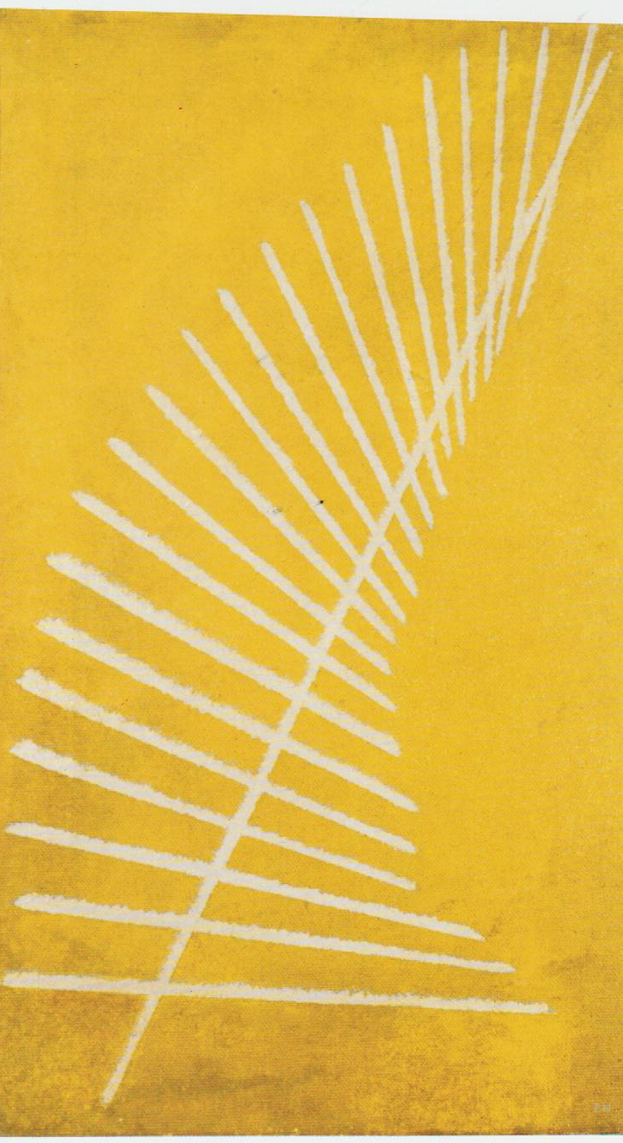
Construction No. 89 (on Light Yellow). 1919. Oil on canvas, 67.5 x 40 cm. Pushkin State Museum of Fine Arts, Department of Private Collections, Moscow

Aleksandr Rodchenko began as a painter and his early non-objective canvases were achieved by beaming rays of light onto a screen (1917-1918). These were followed by his ‘Black on Black’ paintings (1918-1919) of celestial phenomena (eclipses, comets) and his ‘Line paintings’ (1919-1920), called “Constructions”, of pure geometrical spatial arrangements of forces. These works were shown in two major avant-garde exhibitions in Moscow in 1919 and in 1920 – The 10th State Exhibition—Non-Objective Creation and Suprematism and the 19th State Exhibition respectively, the latter including a retrospective of the painting of Vasily Kandinsky. Geometry was fundamental in Russian avant-garde art, and in modernism generally, because artists were interested in the structures of order, from nature to the cosmos. Hence geometry was essential for giving order to their art, especially as it was the only means of capturing and expressing forces, the structures of energy and its movement. That was the explicit subject matter of his non-objective paintings, 1919-1921, several drawings illustrating the catalogue of the famous 5 x 5 = 25 exhibition (Moscow 1921), and discussed by Rodchenko in his article, ‘The Line’ (1920). His modular sculptures of 1920-1921 are three-dimensional explorations of this subject matter and the depiction of forces through the order of geometry are the source of his innovative graphic design throughout the 1920s. It was also basic in his teaching of ‘constructive principles’ at the Vkhutemas, 1921-1928, which was applied in the Metalwork Department and furniture design. Rodchenko was head of the Moscow Art Bureau of IZO Narkompros, 1920-1922, which purchased works by the Russian avant-garde for the network of over 30 Museums of Artistic Culture throughout Russia.

References and further reading:
Selim O. Khan-Magomedov, Rodchenko The Complete Work, Cambridge: MIT Press, 1987.
Aleksandr Rodchenko: Experiments for the Future – Diaries, Essays, Letters, and Other
Writings, ed. by Alexander N. Lavrentiev, New York: MOMA, 2005.
Opyt dlia budushchego – Dnevniki Stati, Pisma, Zapiski, Moscow: RA, 1996.
Peter Noever (ed.), Aleksandr Rodchenko & Varvara Stepanova: The Future is Our Only
Goal, Munich: Prestel Verlag, 1991.
Magdalena Dabrowski, Leah Dickerman, Peter Galassi, Aleksandr Lavrentiev, Varvara Rodchenko, Aleksandr Rodchenko, New York: MOMA, 1998.

